Mobile Print
The mobile print solution allows patrons to send document to the library printer system from both outside and inside the library. This can be accomplished via two methods:
- Mobile Print Web Page
- Mobile Print E-mail
Mobile Print Web
The mobile print web page is accessible by going to the address print.gflibrary.com in a modern web browser such as Internet Explorer 11, Edge, Firefox, Chrome, Safari, as well as mobile browsers on smart phones.
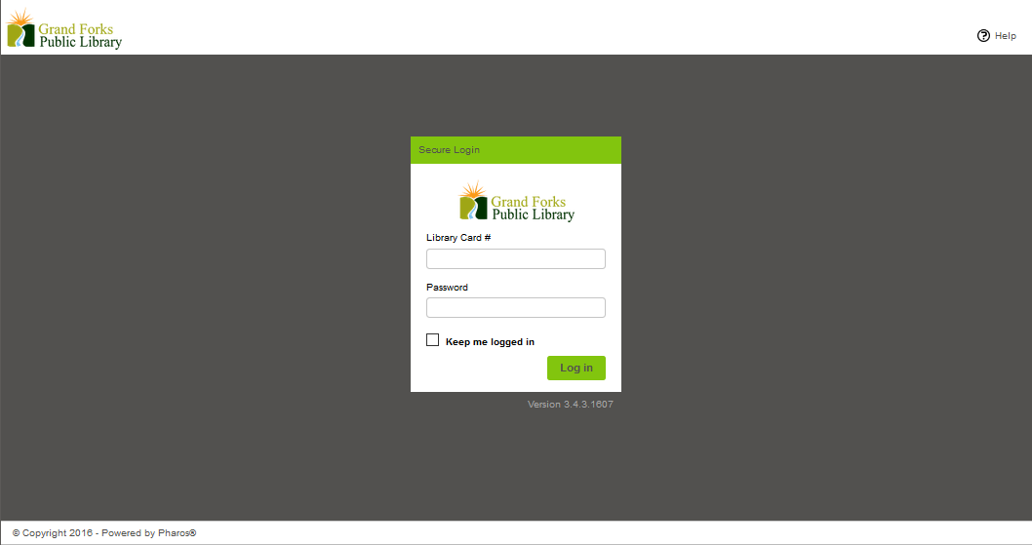
Log on using your library card number and password.
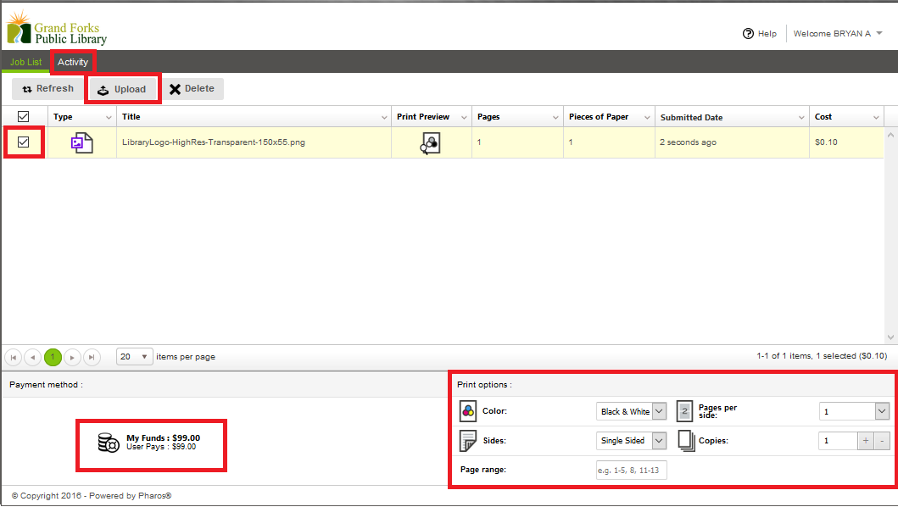
Once you are logged in, you can view the available funds on your card, upload documents to the print queue, delete documents, modify document print settings on selected documents, and view your activity history.
*Please note: Currently, IOS devices will not upload documents-they will have to send it to their email in order to print.
*The Patron Printer will only print 1 page per side even though it offers the option above.
Mobile Print Email
To add a print to the queue using email, send the document as an attachment to the address:
print@gflibrary.com
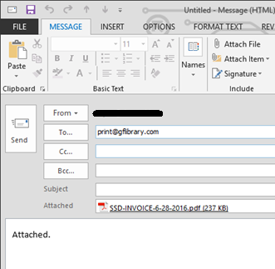
If you have not setup the account, you will get a response email asking you to click the link to verify the account.
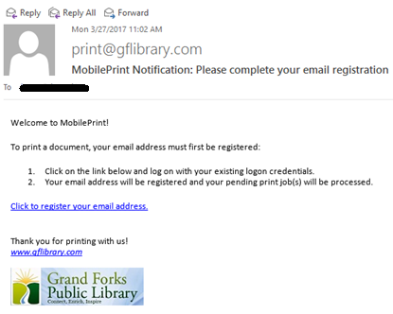
Follow the link “Click to register your email address” to associate your email with your library card number.
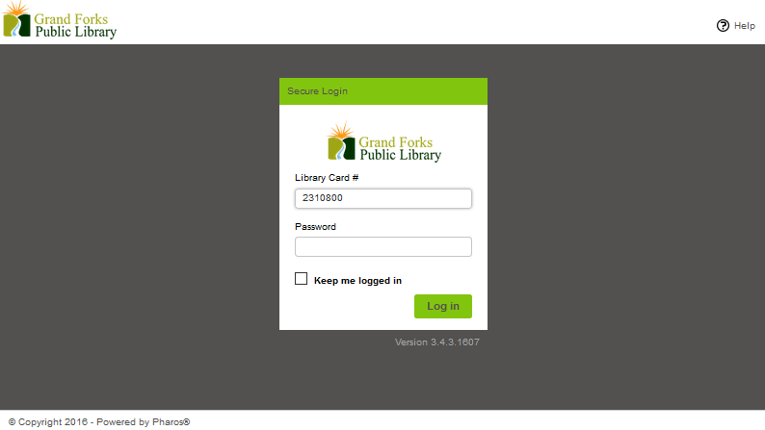
Login using your library card number and password.

You will receive a notification that your email address has been registered:
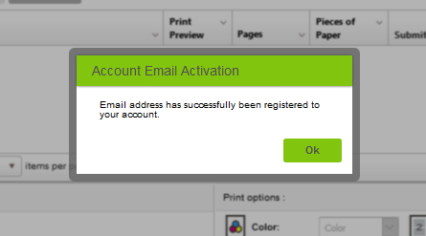
Click “OK” and your document will appear in your print console.
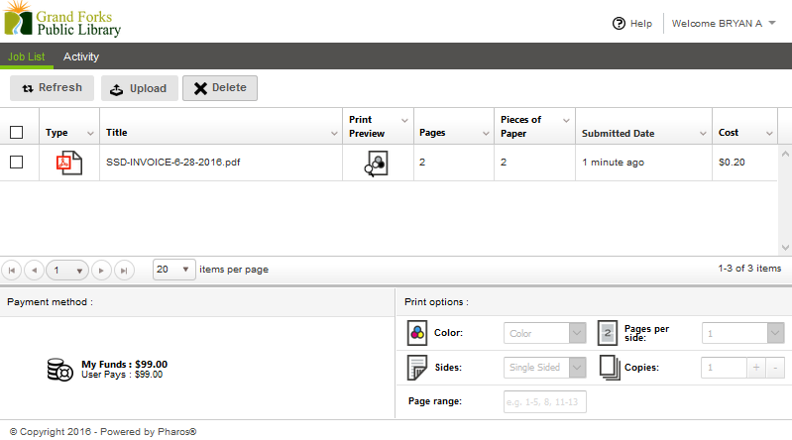
All print jobs will appear in the print queue as normal.
All Jobs are released using the printer release station as before.
Documents submitted via mobile print will stay in the print queue for 10 hours before being deleted.
Documents sent to the print queue via library computer are still queued for 2 hours before being deleted.

