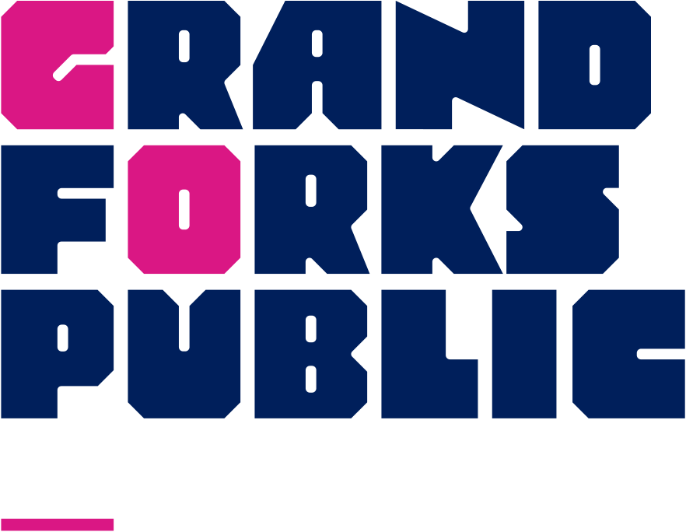

Patron Rights and Responsibilities
The library belongs to everyone. This document exists to ensure an enjoyable library experience for all.

The Grand Forks Public Library Board and staff support the rights of all individuals to:
- Use the library without discrimination
- Receive friendly, respectful and professional service
- Have free and equal access to information
- Have a clean, comfortable and pleasant environment
- Use the library undisturbed without threat of harm, invasion of privacy, or interference

You have the right to privacy.

Library records will only be released when required pursuant to a court order or subpoena. Only the Library Director or her/his designee is authorized to do so. In addition, under the USA Patriot Act guidelines any information posted on the Internet, sent by email, or otherwise stored electronically in libraries or elsewhere, is subject to scrutiny by law enforcement agencies without notification.
You have the right to enjoy a clean, comfortable, safe environment.
To ensure a clean, comfortable, safe environment:
- Bring library materials back. Returning items in a timely manner and good condition will ensure all patrons can enjoy materials.
- Take care of the materials, equipment, and furniture within the library. Help us maintain a welcoming environment by keeping the space tidy and cleaning up after yourself.
- Your safety is important. Illegal substances or alcoholic beverages are not allowed in the library or on library grounds. Tobacco products may be used beyond twenty (20) feet of the library building as pursuant to NDCC 23-12-10. Intoxication resulting from the use of alcohol or drugs is also prohibited in the library and on library grounds. For your safety, the ambulance may be called if you are found intoxicated or needing medical care.
- Seating works on a first-come, first-served basis. Tables are not reserved for gatherings, but you are welcome to find a cozy spot. (Note: Sometimes library space is reserved for programming.)
To ensure your right to use the library disruption-free:
- Be kind. Your words and actions should be welcoming and compassionate.
- Be comfortable; this is your library. Shirt and shoes must be worn at all times. Follow public health safety protocols.
- Be mindful of your belongings and surroundings to ensure safety for everyone navigating the library.
- Be considerate of others when talking or using devices. We want to ensure an enjoyable library experience for all.
- Surveys conducted in the library or on library grounds need to be approved by the Library Director.
- Library staff is here to help you and make your library experience enjoyable. Please listen and abide by their requests.
To ensure the safety of children:
- Parents are responsible for the behavior and supervision of their children. Please keep a close eye on your children and ensure they are respectful of other library users.
- Children ages eight and under* can enjoy the library if they are supervised by a parent or guardian. Know where your children are in the library and keep children near you at all times. Library staff must give their attention to all patrons, so children should not be left unattended.
*In accordance with the North Dakota Department of Human Services recommendations.
Any illegal acts are prohibited in the Library and will be reported to law enforcement authorities. Soliciting, selling, or begging is not permitted in the Library.

The Library Director or Department Supervisors may deny library access or service to any patron violating the above guidelines. Patrons whose privileges have been denied may request a review by the Library Board.

Library visitors are asked to cooperate with the library staff who must interpret and apply this policy. The intention of these principles is to help promote excellence in library service for all patrons and ensure library visitors’ ability to freely use the Library in comfort.

Approved by Grand Forks Public Library Board 8/12/2010; 5/30/2013; 5/17/2017; 1/16/2019; 12/16/2020, 2/16/2022; 8/21/24

